A000-Asia-Mesopotamia-Sumeria-Enuma Elish-Petroglyph-2000 BCE

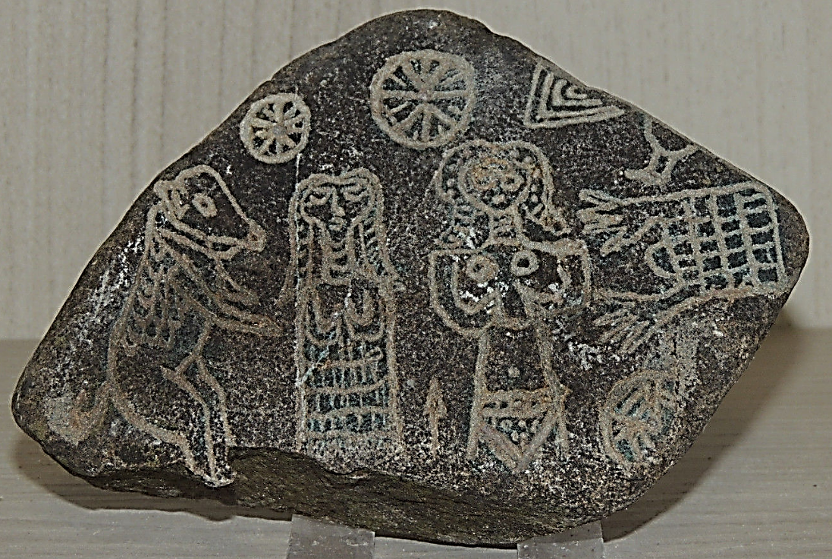

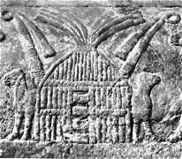 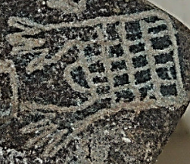

Petroglyphs of Mudhifs, Sumerian reed houses.

This petroglyph panel from the area near Sumer in southeastern Iraq. It is a story-board of the great Sumerian liturgy, Enuma Elish, embodying the myth of creation as it was current in Sumer from about the middle of the second millennium BCE. The Creator God Gilimma and his consort stand beneath the Sun and the Moon respectively, creating the first cattle. To the left of Gilimma’s consort is the holy reed house that was made possible by Gilimma who “bound the reeds in the face of the waters.” The descendants of the Sumerians c 2000 BCE are the Marsh Arabs ([Arabic](https://en.wikipedia.org/wiki/Arabic_language): عرب الأهوار‎ ʻArab al-Ahwār "Arabs of the Marshlands") or Maʻdān ([Arabic](https://en.wikipedia.org/wiki/Arabic_language): معدان‎ "dweller in the plains"). Below is an extract from the creation myth:

No city had been created, no creature had been made,

Nippur had not been created, Ekur had not been built,

Erech had not been created, Eanna had not been built,

Apsû had not been created, Eridu had not been built,

Of the holy house, the house of the gods, the habitation had not

been created.

All lands were sea.

At the time when a channel (was formed) in the midst of the sea,

Then was Eridu created, Esagila built, etc.

…….

Gilimma bound reeds in the face of the waters,

He formed soil and poured it out beside the reeds.

[He]filled in a dike by the side of the sea,

[He . . .] a swamp, he formed a marsh.

[. . .], he brought into existence,

[Reeds he form]ed, trees he created.

Here the Sumerian Creator is pictured as forming dry land from the

primaeval water in much the same way as the early cultivator in the

Euphrates Valley procured the rich fields for his crops. The existence

of the earth is here not really presupposed. All the world was sea until

the god created land out of the waters by the only practical method that

was possible in Mesopotamia.

References: King, Leonard W. 2010. Legends of Babylon and Egypt in Relation to Hebrew Tradition. New York: Cosimo Classics.

[30°30′N 47°49′E](https://tools.wmflabs.org/geohack/geohack.php?pagename=Basra&params=30_30_N_47_49_E_region:IQ_type:city(2150000))